**GOVERNMENT ARTS AND SCIENCE COLLEGE, KOZHIKODE**

**NATIONAL SERVICE SCHEME (UNIT NO.17 & 107)**

**ANNUAL REPORT 2021 – 2022**

The NSS unit of Government Arts and Science College functioning under the leadership of NSS Programme Officers are Hanna Thamleena (Assistant Professor of Chemistry) and Fasal.c (Assistant Professor of History). The NSS GASC unit has achieved remarkable heights in the past few years. The total strength of the unit is 200. The first year students constituted 100 volunteers and second year students constitute 100 in strength. Two units of first year was led by Nayana J, Vinil Vasu, Anamika K T and Sahil Vasid. C. The Two units of second year was led by Mridul, Shinu, Gopika and Anaswara.

2021- 2022 was a post covid period in which college slowly shifted to offline mode activities. But NSS arts college unit had done remarkable activities this year following the covid protocol. The activities are listed below.

**POSTER MAKING COMPETITION ON WORLD AIDS DAY – DECEMBER 1**

NSS units and Red Ribbon Club of the college jointly organized a poster making completion in connection with World Aids Day for the students of the college. Amisha K P and Nandana Suresh from first semester Chemistry won first and second prizes respectively.

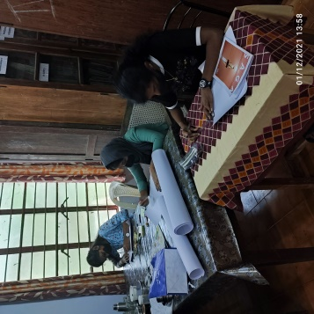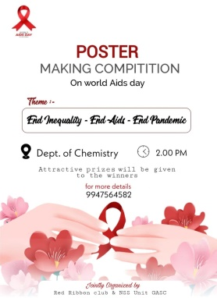

**BLOOD DONATION CAMP – DECEMBER (16-12-2021)**

NSS and NCC units of the college jointly conducted Blood donation camp. 61 unit blood donated and the program was successful in increasing the awareness of importance of blood donation among our students.

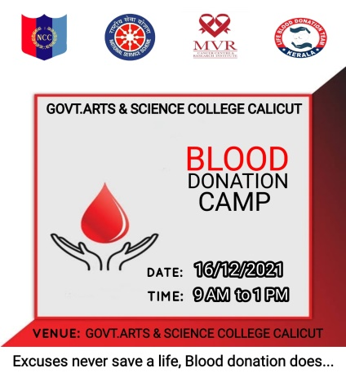

**CAMPUS CLEANING – DECEMBER**

In connection with the selection of first year volunteers, NSS units of the college organized an intense campus cleaning program. The students applied for membership was divided into a number of small groups and the activities of each group were monitored by a set of teachers. Each student were interviewed thoroughly about their capabilities and vision as a social servant and based on their activities and interview teachers made a score sheet of marks they obtained.

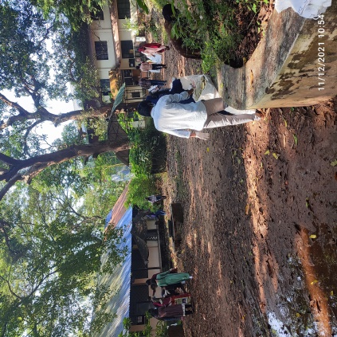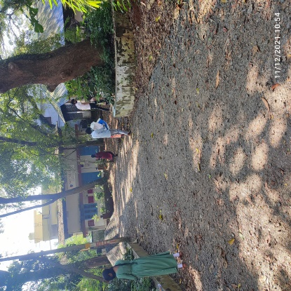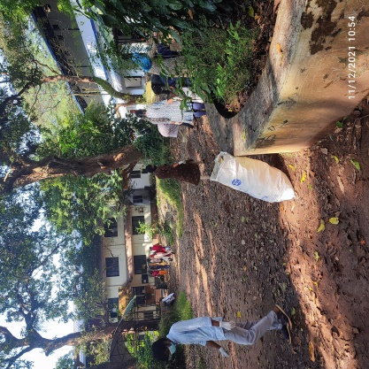

**NSS SPECIAL CAMP – 27/12/21 TO 02/01/22**

Due to the pandemic situation, NSS units of the college conducted a special camp “ASHNA” in the campus itself. A total of 92 students participated in the camp. The volunteers involved in campus cleaning and beautification activities. Many classes and creative Workshops were conducted in the context of the main theme-‘women empowerment’.

**Day one, December 27-12-2021**

Registration of NSS special camp started exactly at 3 p.m. All volunteers submitted their RT-PCR results and parent’s consent letter during the registration. A total of 92 volunteers registered for the special camp.

The camp was inaugurated at 4 p.m. by raising the flag. Welcoming remarks were made by Mr. Fasal, NSS Programme Officer. The function was presided over by Dr. Edakkotte Shaji, Principal of Govt. Arts and Science College, Calicut. The Programme was inaugurated by Dr. S. Jayasree, Standing Committee Chairperson of Calicut Corporation.

**Ice Breaking:**

Ice breaking session was handled by Prof. Imbichi Koya K., Former Hon., Economics Department. This session helped to create love and friendship among the volunteers. It also helped to bring out the various talents of the volunteers. Volunteers were divided into different groups after the ice breaking session.

**Day two, December 28-12-2021**

Second day started with a warm up session. This session was handled by Megha, NSS volunteer. Al volunteers exercised with music. After this NSS assembly began with the NSS song.

**Campus Cleaning**

Volunteers gathered at areas allotted for them for cleaning. A part of the campus was very nicely cleaned by the volunteers by 12 p.m.

A Session was conducted at 2:30 p.m. by Ali Ajmal Chembakasherry, who has attended NSS National Camp and was an Alumni of Govt Arts and Science College, Calicut. This session helped to bring out the talents in volunteers such as singing and dancing.

**Cultural Programs**

Cultural program was conducted under the leadership of group 2. it was a great opportunity for the volunteers to showcase their talents.

**Day three, December 29-12-2021**

## Morning Assembly

3rd day started with doing exercise.Assembly was conducted under the leadership of the group 3.The review of the previous day was presented to the assembly in the form of a newspaper.

**Campus Cleaning**

Campus cleaning started exactly at 9AM.Another part of the campus was decided to be cleaned. Each group completed the cleaning process in the best possible way.

A talk conducted about the topic, ‘Justice, Equality and Safety for the youth- Jesy’ at 3pm this session was handled by Nidhniya Pattayil (Actress, and teacher of Farook college TTI ) and Dr. R. S. Vasudhevan (Senior lecturer, DIET Kozhikode ) They made the students aware of the topic through drama. It was a different experience for the volunteers.

**Cultural Programs**

Cultural program was conducted at 7PM under the leadership of group 3. The program consisted of dance,songs and games.

After the camp review at 9.30 ,light off was done at 10.30 PM.

**Day four, December 30-12-2021**

## Morning Assembly

After the warm up section assembly was conducted by the group 4.NSS song and presented the newspaper about previous day.

**Campus Cleaning**

Campus cleaning started at 9 PM.Volunteers cleaned the surroundings of library.Cleaning was nearly done.

**Project Work**

Project work was campus painting. **‘Thoni ’** near the library, resting place and fence of garden were painted.Volunteers had so much fun painting together.

**Snehapoorvam**

Volunteers had a feast by the 3rd years.This session helped to strengthen the love and friendship among the volunteers.A cake was cut at the Malayalam department by the 3rd years and distributed to all volunteers.The camp became so much active in their presence

**Camp review**

Volunteers discussed about the camp.They appreciated different groups for their good work.

Light off was done at 10.30 PM.

**Day five, December 31-12-2021**

## Morning Assembly

After warm up section the group 5 conducted the assembly.NSS song and Newspaper presented in the assembly.

**Project Work**

Resting spots were created by each group on their favorite sites.These spots were created by using waste materials.

**Talk/Discussion**

A discussion on the topic ‘Love and Safety of women’ was conducted at 3PM. This discussion was of the nature of a debate. This session was handled by DR. Sona Eepa (Assistant Professor, Malayalam department).

**Cultural program**

Cultural program was conducted at 7 p.m. under the leadership of group 6

**Camp Night**

The volunteers prepared a candle night dinner.All the volunteers shared their love by sharing food with each other.It was a very emotional moment for volunteers.

**New Year Celebration**

New year was celebrated by cutting the watermelon.Each volunteers shared watermelon to another volunteer who had become best friends after meeting at the camp.After that a review session conducted

**Day six, December 01-01-2022**

**Project Work**

Volunteers finished the construction work of the resting spots.They beautified the spots by decorating it with painted bottles and other waste materials

**Folk Song**

Sooraj and team made the 6th day night more exciting. All volunteers sang with them and danced to the beats.

**Day Seven , December 02-01-2022**

Volunteers cleaned the campus before the concluding session

**Concluding Session**

DR EDAKOTTE SHAJI (Principal Govt Arts and Science College Calicut) inaugurated the concluding session.

**BEST CAMPERS :** Anaswara SL and Fiyas Hussain

**BEST PERFORMER :** Jishnu K

**BEST GROUP :** GROUP 3

**SEMINAR ON INTERNATIONAL WOMEN’S DAY**

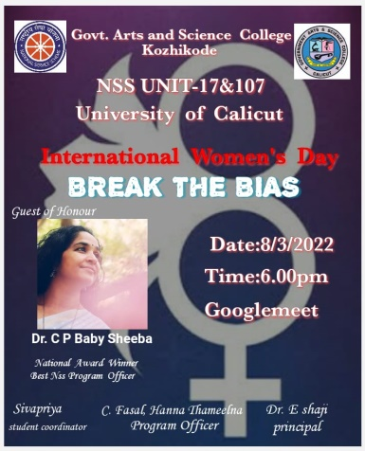NSS units organized an online seminar based on the theme ‘break the bias’ on 08/03/22. Dr. C P Baby Sheeba, National Award Winning NSS programme officer and Associate professor of Malayalam Department had given a very relevant talk on women empowerment.

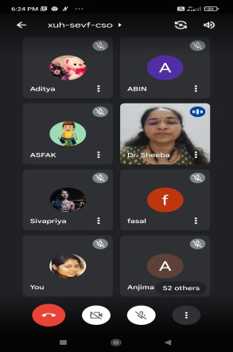

**SEMINAR FIRST YEAR VOLUNTEERS- 10/03/22**

NSS units and Jeevani (counseling centre) of the college jointly organized a workshop “ Becoming a V olunteer-importance of psychological well-being”’ for the first year NSS volunteers. Jaleel Cholayil, Psychologist, HOD of the Psychology department, Sheraz Campus, Malappuram was the speaker. The students could enjoy the very informative and helpful session in the context of personality development and mental well-being.

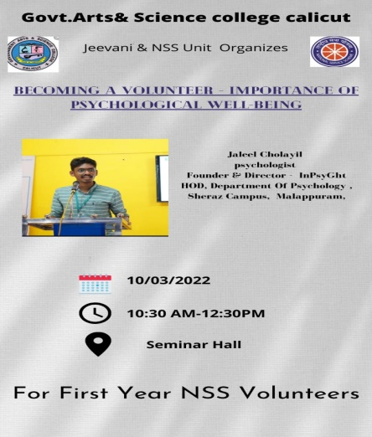

**WORLD KIDNEY DAY (11-03-2022)**

As a part of the World Kidney Day, NSS Unit and Iqra Hospital Kozhikode jointly conducted a progamme “Kidney health for all”. Dr. Shafeeque Rahman, Nephrology department, Iqra Hospital, lead the class.

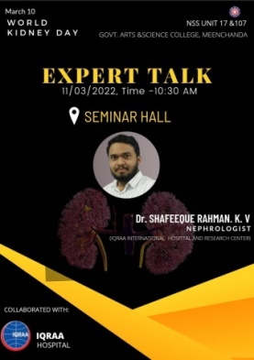

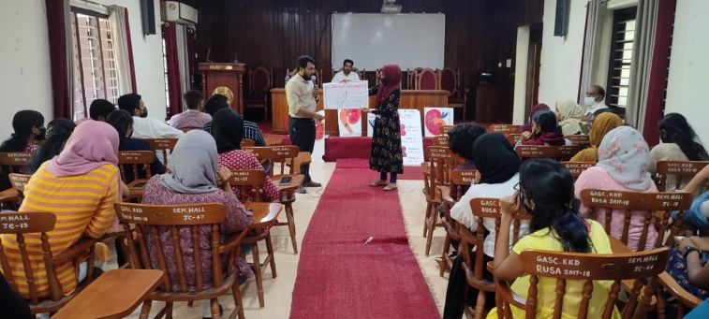

**VISIT OF DIFFERENTLY ABLED STUDENTS (14-03-2022)**

24 Differently abled school students, their parents and teachers visited College Library, Zoology lab and Botany Garden. NSS Volunteers guided and provided all assistances to the students.

**ORIENTATION PROGRAM FOR FIRST YEAR NSS VOLUNTEERS (17-03-2022)**

P Sreenivasan, Trainor and motivational speaker, inaugurated and lead the orientation class.

